NAME:_________________________________ DATE:__________
WINTER BREAK HOMEWORK PACKET DUE:____________

DIRECTIONS: SHOW ALL WORK TO RECEIVE FULL CREDIT.

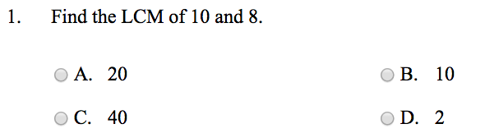

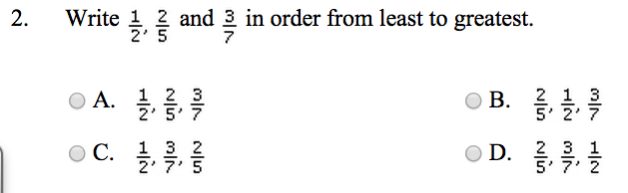

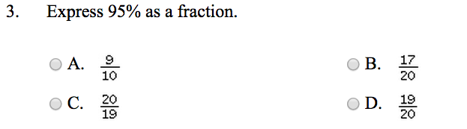

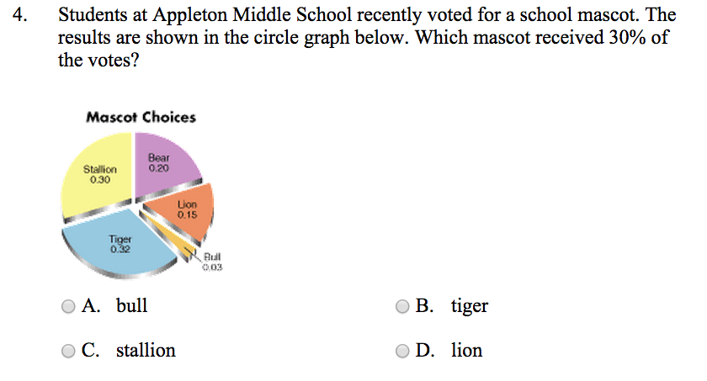

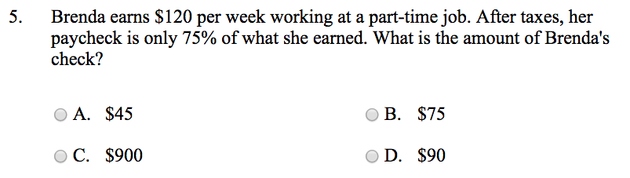

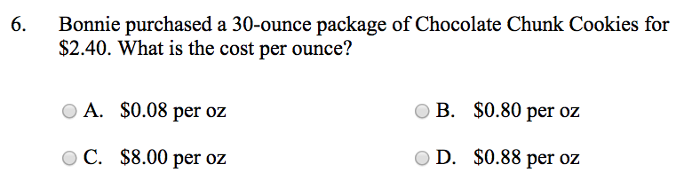

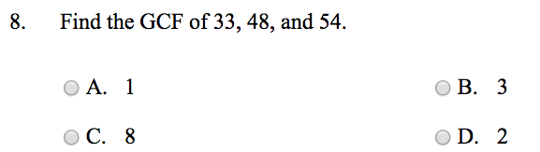

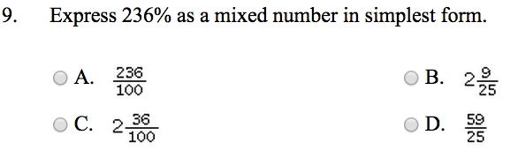

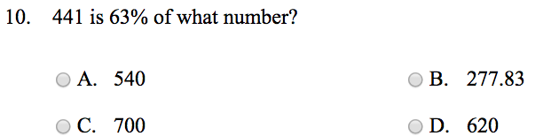

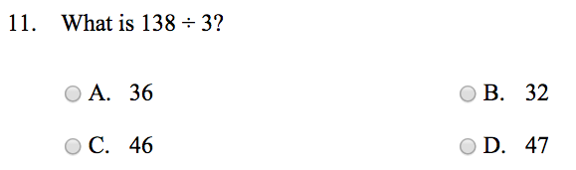

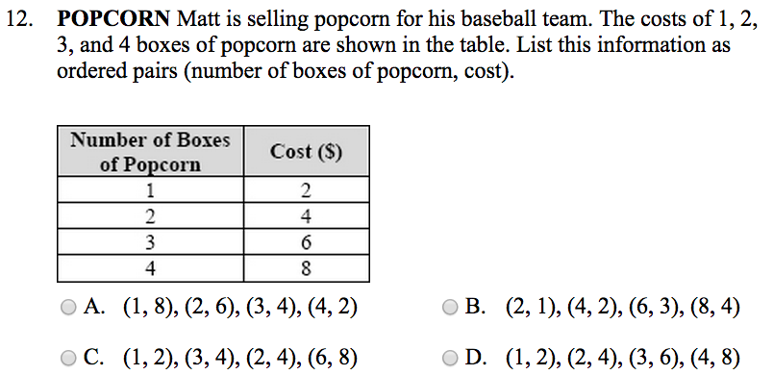

SHORT ANSWER QUESTIONS:

