14. An artist is using tiles in the shape of a parallelogram to make a mosaic. The tiles have the dimensions shown. What is the area of one tile?
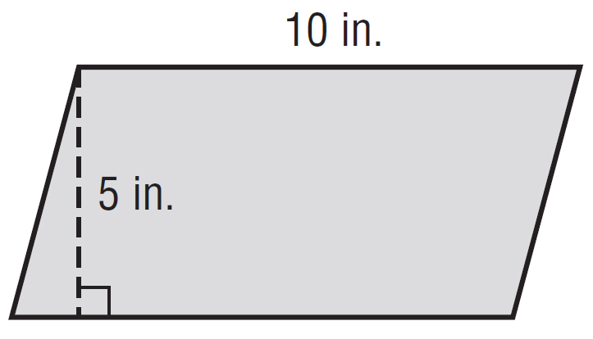

15. What is the height of a parallelogram with base 7 meters and an area of 84 square meters?

16. What is the area of the triangle?

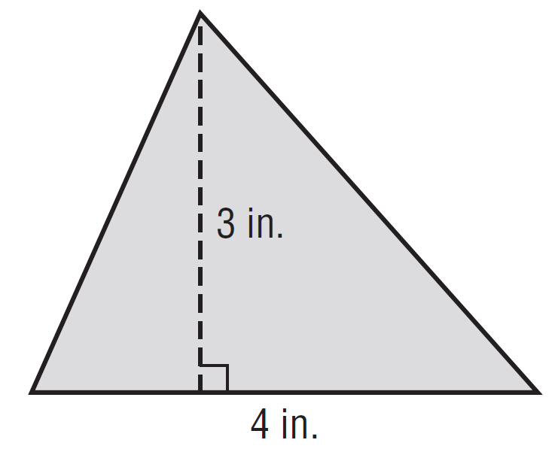

17. An eraser has the dimensions shown at the right. What is the area of the eraser?
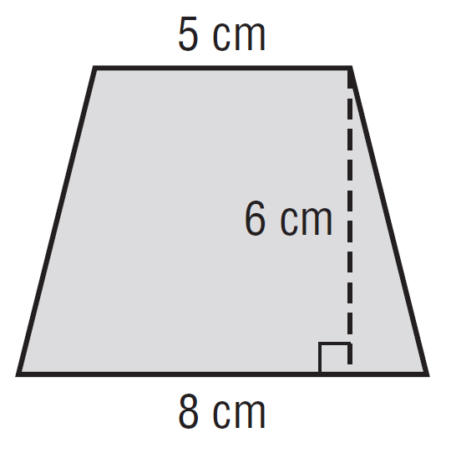

18. The blueprints for a new garden are shown. Each grid square on the blueprint has a length of 10 feet. What is the total distance, in feet,
around the garden?
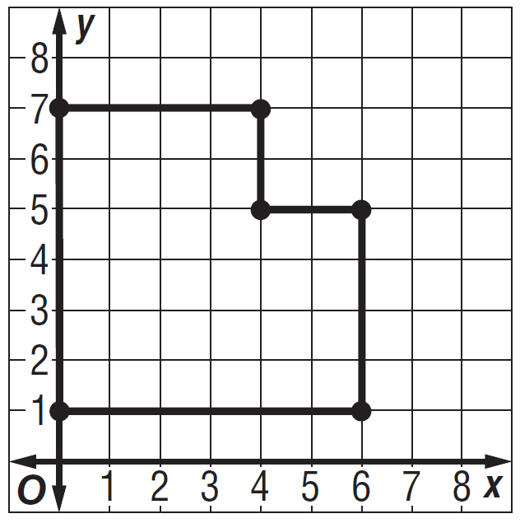

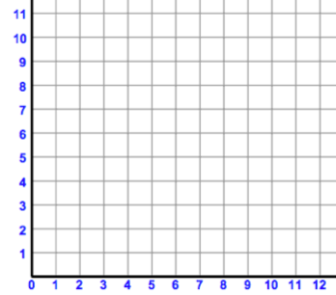
19. A rectangle has vertices A(1, 2), B(1, 7), C(4, 7), and D(4, 2). What is the perimeter of the rectangle?

A. 3 units C. 15 units
B. 5 units D. 16 units

20. What is the area of the figure shown below?
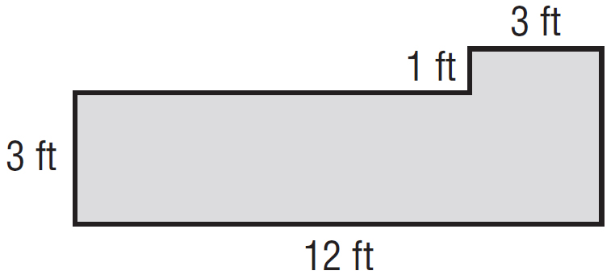

21. What is the surface area of the rectangular prism below?
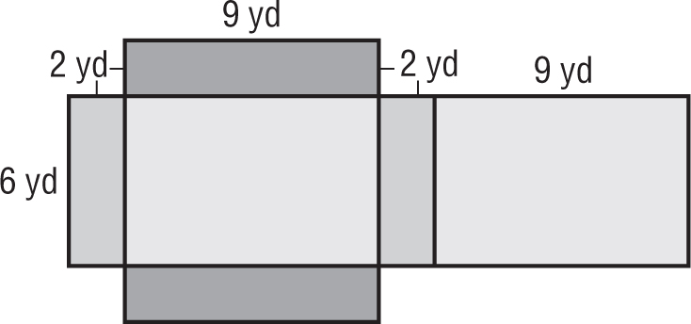

22. What is the volume of the rectangular prism?
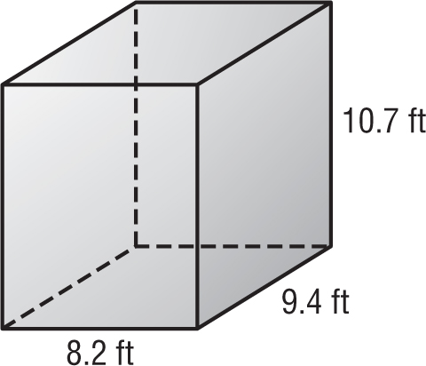

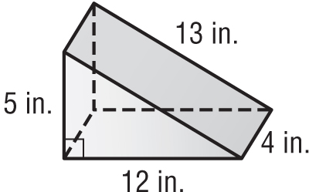
23. What is the surface area of the triangular prism?
F. 150 ${in}^{2}$ H. 240 ${in}^{2}$
G. 180 ${in}^{2}$ I. 3,120 ${in}^{2}$

24. What is the volume of the prism?

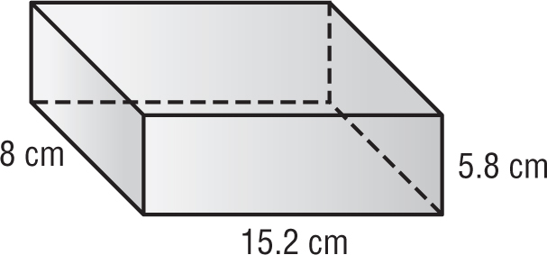

TEMPERATURE The temperature in Georgia was recorded for 6 days in November.
The temperatures were 62°, 60°, 70°, 78°, 60°, and 66°.

25. What is the mean for the data?

26. What is the median for the data?

27. What is the mode for the data?

For Exercises 28 and 29, use the dot plot which shows the prices for different pairs of sunglasses.

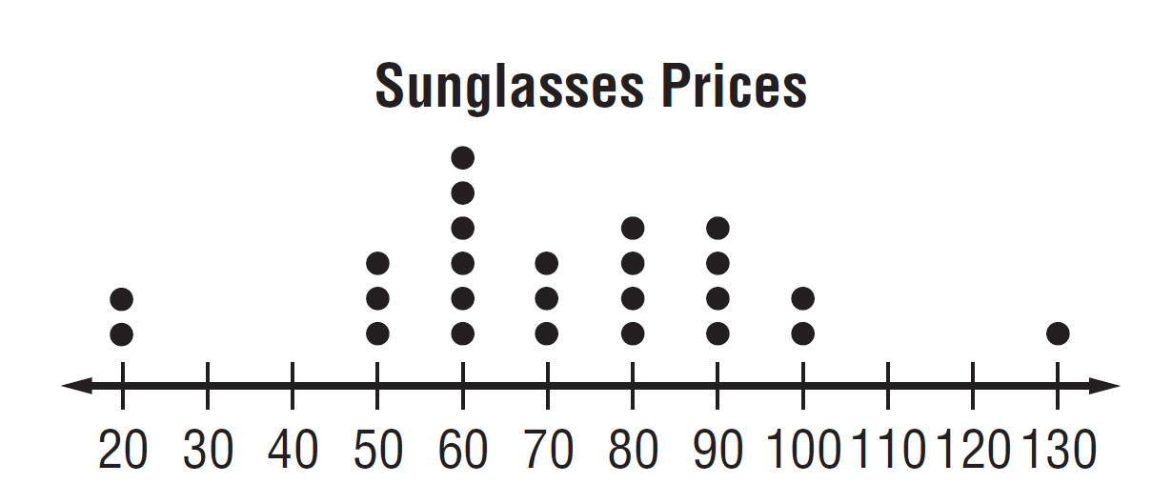

28. What is the range of the data?

29. Find the mean, median, and mode.

Mean _____________________ Median _____________________Mode_____________________

Answer the following question in full sentences! Provide an example to help boost your answer.
30. What is an outlier? What measure of center does it affect? Which measures of center does it not affect?

