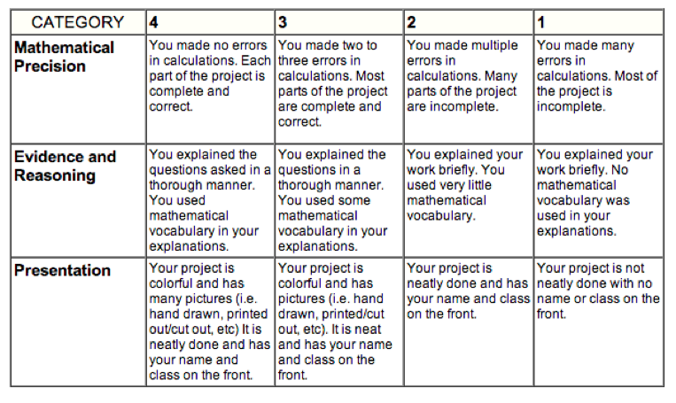

Glow: | Grow:
Score:

