AT YOUR SEAT :SHEET A

Solve Two-Step Equations

Solve each equation. Check your solution.

1. 2x + 1 = 9 2. 5b + 2 = 17

9. 2 + $\frac{1}{6}$a = –4 10. 9 + 4b = 17

17. 11x – 24 = –2 18. 15a – 54 = –9

23. –5b + 24 = –1 24. –6x + 4 = –2

AT YOUR SEAT :SHEET B

Solve each equation. Check your solution.

1. $3(x + 5) = 18$ 2. $4(x + 8) = 44$ 3. $-5(x - 10) = -35$

7. $\frac{2}{3}\left(x+13\right)=22$ 8. $-\frac{7}{9}\left(x+3\right)=14$ 9. $-\frac{4}{7}\left(x-\frac{1}{4}\right)=\frac{3}{7}$

10. $\frac{5}{8}\left(x-\frac{1}{3}\right)=\frac{5}{12}$ 11. $8.3(x + 3.1) = 83$ 12. $-7.2(x - 15.6) = -9$

Write an equation to represent each situation. Then solve the equation.

13. SCHOOL Half of the students in Max’s class volunteer at the local community center. Fifteen students do not volunteer. If there are 12 boys in Max’s class, how many girls are in his class?

(x + 3.3) m
14. GEOMETRY The perimeter of the square shown is 4(x + 3.3) meters. What is the value of x if the perimeter is 28 meters?

15. SUPPLIES Tony spent $60.54 and bought 3 packs of notebooks and a calculator. How much does a pack of notebooks cost if a calculator costs $45.87?

AT YOUR SEAT :SHEET C

More Two-Step Equations

1. The length of each side of a square is increased by 6 inches, so the perimeter is now 36 inches. Write and solve an equation to find the original length of each side of the square. | 2. Madison and her sister received the same amount of money to go out to eat. Each girl spent $13. After lunch, the girls had a total of $4. Write and solve an equation to find the amount of money each girl received.
3. Mrs. Palmer bought one pair of goggles, one bathing suit, and one beach towel for each of her three daughters.  Item Price ($)  Goggles 6  Bathing suit 25  Beach towel 13  Suppose she had $18 left after buying the swimming items. Write an equation to find the amount Mrs. Palmer originally had to spend on each daughter. | 4. William gave 4 football cards to each of his 6 friends. Suppose he had 54 cards left. Write and solve an equation to find how many cards each friend initially had.
5. For each month of a year, Selena saved an extra $100 from her paycheck. By the end of the year, she has saved $1,800. Write and solve an equation to determine how much she typically saved from each paycheck. | 6. Mr. Kelly bought the ingredients to make trail mix. He bought 1.5 pounds of peanuts and spent $22.50 on peanuts and chocolates.  Ingredient Price per Pound ($)  Peanuts 4.50  Raisins 2.00  Chocolates 4.50  Write and solve an equation to determine the number of pounds of chocolates Mr. Kelly bought.

TEACHERS CHOICE
Steps to solving two-step word problems:
1. Read the problem carefully. Underline any key information.
2. Write a let statement.
3. Write an equation.
4. Solve the equation.
5. Check your answer
‘

Example 1:Nick opens a savings account with $50. Each week after, he deposits $15. In how many weeks will he have saved $500?

Step 1: Underline any key information

Step 2: Write a let statement. What does our variable represent?

Step 3: Write an equation:

Step 4: Solve the equation:

Step 5: Re-read the question. Does your answer make sense?

Example 2: Alex rents a car for one day. The charge is $18 plus $0.12 per mile. Alex wants to spend exactly $30. How many miles can he drive? Complete the same steps in Example 1.

Example 3:
Katie wants to buy a bicycle that costs $129. This is $24 more than 3 times what she saved last month. How much did she save last month?

MATH FACTS
Please log onto Mathletics and complete the assigned topics.

COMPUTER ZONE
Please go onto the msnapoli.weebly.com site under 613
Game 1: http://www.math-play.com/Two-Step-Equations-Game.html
Game 2: https://braingenie.ck12.org/skills/105348

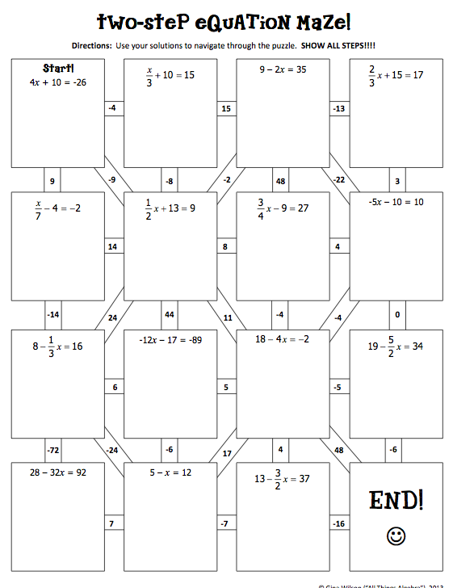
HANDS ON

