Review Sheet for Proportional Relationship Test

1. Which fraction represents the ratio 5 roosters out of 15 chickens in simplest form?
A. $\frac{3}{10}$ B. $\frac{1}{3}$ C. 3 D. $\frac{10}{3}$

2. Which fraction represents the ratio 2 quarts to 1 gallon in simplest form?
F. $\frac{1}{8}$ G. $\frac{1}{4}$ H. $\frac{1}{2}$ J. 1

3. Alexandro buys 7 pounds of cauliflower for $10.78. What is the unit price of the cauliflower?
-

4. Which rate has the same unit rate as 200 jumps in 5 minutes?
F. 120 jumps in 1 minute
G. 240 jumps in 6 minutes
H. 300 jumps in 8 minutes
J. 900 jumps in 10 minutes

7. The cost of 6 tacos is $13.20. If the cost is proportional to the number of tacos ordered, which of the following prices is not an equivalent rate?
A. 2 tacos for $4.40
B. 8 tacos for $17.60
C. 9 tacos for $19.80
D. 3 tacos for $6.20

8. LinLo rode her scooter for $\frac{1}{3}$ hour and traveled 2$\frac{1}{6}$ kilometers. What is her average speed in kilometers per hour?

9. The graph of the relationship (dogs, cost) is a line that contains the points (0, 0), (3, 12), and (6, 24). What is the constant of proportionality?
A. $\frac{1}{9}$ B. $\frac{1}{4}$ C. 4 D. 9

10. Which statement best describes the relationship in the table?

Months | 12 | 24 | 36 | 48
Years | 1 | 2 | 3 | 4

F. The constant of proportionality is 0.
G. The constant of proportionality is 4.
H. The number of months is proportional to the number of years.
J. The number of months is not proportional to the number of years.

12. At the same time a 5-foot girl casts a 4-foot shadow, a nearby stop sign casts an 8-foot shadow. How tall is the stop sign?
F. 9 feet G. 10 feet H. 12 feet J. 16 feet

For Exercises 13 and 14, use similar triangles ABC and FGH.
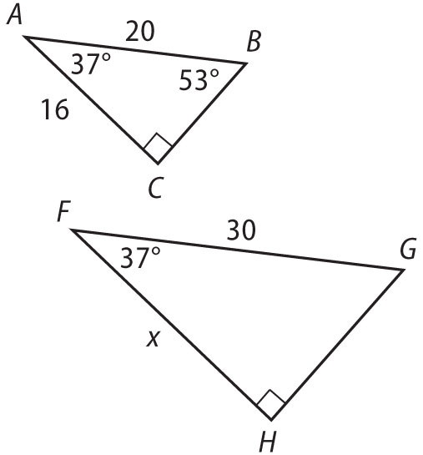
13. Which statement is not true?
A. ∠H ≅ ∠C
B. $\overline{AC}$ corresponds to $\overline{FH}$
C. $\overline{BC}$ corresponds to $\overline{GF}$
D. <B ≅ <G

14. What is the measure of <H? _________

15. What is the measure of <G ? _________
16. What is the value for x? _________

