Name: ________________________________________

Class: ________________________________________

Due Date: ________________________________________

Spa Day Project!

Now, it’s your turn to be creative while working with the distributive property!

Standards: 6.EE.A3
Apply the properties of operations to generate equivalent expressions. For example, apply the distributive property to the expression.

Here’s how you will be graded:
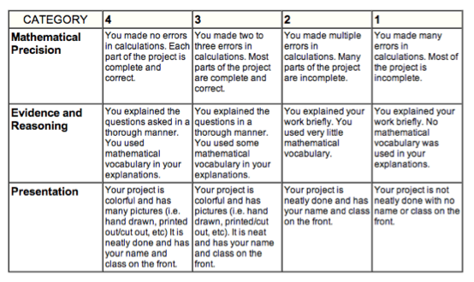

Part 1
The Boody Spa provides two luxurious places to hang out. The Pool and Hot Tub located on the 5th floor. Before the final plans are set and done, you need to help the contractors with a few calculations.

Find the perimeter and area of both the pool and hot tub two different ways.
(Using both the distributive property and order of operations.)

Pool | Hot Tub
Area:  Distributive Property | Area:  Order of Operations  Use x = 8  Distributive Property
Area:  Order of Operations  Use x = 4 | Area:
Perimeter:  Distributive Property | Perimeter:  Distributive Property
Perimeter:  Order of Operations  Use x = 4 | Perimeter:  Order of Operations  Use x = 8

Part 2
Next, the contractors are up for fun suggestions. They have some space for an extra pool or hot tub. Be Creative!!

Choose between a pool or a hot tub. Circle one: Pool or Hot Tub

Choose the length to be a number between 2 and 10: Length: _________

Choose the width to be an algebraic expression using addition: Width:____________

Use the grid paper to display your new creation, and then find the area and perimeter of your pool or hot tub below using both the distributive property and order of operations.

Choice: Hot Tub OR Pool

Distributive Property
Area:

Order of Operations
Use x = 4
Area:

Perimeter:
Distributive Property

Perimeter:
Order of Operations
Use x = 4

Part 3
Critical Mathematical Thinking

a) Cindy gave the following answer on her math test:

Expand: 3 (5x + 4) = 15x + 4

What mistake did Cindy make? What is the correct way to solve this problem?

b) Which of the following expressions represents the perimeter of the figure below:
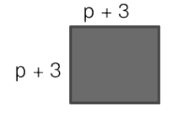
- 2(p+3)
- 4(p+3)
- 4p + 6

Explain your answer choice:

