Magnet February Break HW

1. Which two points represent integers with the same absolute value?
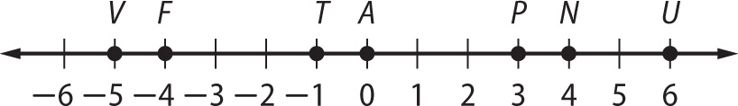

A. points V and U
B. points F and P
C. points T and A
D. points F and N

2. SHORT ANSWER Danielle owes her brother $40. She pays him $25. Write an integer to represent how much she still owes her brother. Explain how you solved.

3. Which decimal is equivalent to $\frac{19}{30}$?
F. 0.63
G. 0.6$\overline{3}$
H. 0.$\overline{63}$
J. 0.06$\overline{3}$

4. Suppose a submarine is diving from the surface of the water at a rate of 80 feet per minute. Which integer represents the depth of the submarine after 7 minutes?
A. 80
B. 560
C. –80
D. –560

5. Suppose a 24-acre plot of land is being divided into
$\frac{1}{3}$-acre lots for a housing development project. What
is the greatest number of lots possible in the development?
F. 8 lots
G. 27 lots
H. 56 lots
J. 72 lots

6. A foreign exchange student wants to ship her belongings to her destination. The mass of each of three packages is shown in the table. What is the total mass of all three packages?

Package | Mass (kg)
A | $22\frac{3}{8}$
B | $26\frac{1}{4}$
C | $18\frac{5}{8}$

A. $66\frac{1}{4}$ kilograms
B. $66\frac{9}{20}$ kilograms
C. $67\frac{1}{4}$ kilograms
D. $67\frac{9}{20}$ kilograms

Magnet February Break HW

7. Which mathematical property is illustrated below?
ab + c = c + ab

F. Commutative Property of Addition
G. Commutative Property of Multiplication
H. Associative Property of Addition
J. Associative Property of Multiplication

8. SHORT ANSWER The table shows Elizabeth’s scores for 9 holes of golf. Add the numbers in the middle column to find her total score for 9 holes. Add the integers in the third column to find her total score relative to par.

Hole | Score | Relative to Par
1 | 4 | 0
2 | 5 | +1
3 | 3 | 0
4 | 4 | 0
5 | 7 | +2
6 | 5 | +1
7 | 4 | 0
8 | 5 | +1
9 | 2 | –1
Totals | ? | ?

9. Which of the following rational numbers is equivalent to a terminating decimal?
A. $\frac{17}{20}$

B. $\frac{17}{22}$

C. $\frac{17}{24}$

D. $\frac{17}{26}$

10. The thickness of a CD is about $\frac{1}{20}$ inch. If Carrie has a stack of 52 CDs, what is the height of the tack?
F. $2\frac{3}{5}$ inch

G. $2\frac{1}{2}$ inch

H. $\frac{5}{13}$ inch

J. $10\frac{3}{5}$ inch

11. Angela painted $\frac{3}{8}$ of a room. Todd painted $\frac{2}{5}$ of the same room. What part of the room has been painted?
A. $\frac{1}{40}$

B. $\frac{5}{13}$

C. $\frac{31}{40}$

D. $\frac{15}{16}$

Magnet February Break HW

12. Overnight the low temperature dropped to –6 degrees Fahrenheit. If the high temperature during the day was 11 degrees Fahrenheit, what was the difference between the high and low temperatures?
F. 5°F
G. 17°F
H. –5°F
J. –17°F

13. SHORT ANSWER The French Club is hosting a breakfast each Monday morning in the cafeteria.
The breakfast menu is shown in the table.

French Club Festival
Crepes  Croissants  Danish  Juice | $2.00  $3.00  $5.00  $1.00

Write an algebraic expression that can be used to find a customer’s total cost given that, c = crepes,
s = croissants, d = Danish, and j = juice.

Find the total cost if the football coach buys
8 crepes, 5 croissants, and 4 juice drinks.

14. A player’s baseball average is found by dividing the number of hits by the total number of times at bat.
A player has a batting average of 0.325.
What fraction is equivalent to 0.325?
A. $\frac{8}{25}$
B. $\frac{4}{13}$
C. $\frac{13}{40}$
D. $\frac{32}{100}$

15. A helicopter descended –50 feet in 4 seconds.
What value represents this change in height?
F. –12.5 feet per second
G. –46 feet per second
H. –54 feet per second
J. –200 feet per second

16. Constance wants to sew trim around the sleeves and collar of a gymnastics leotard. She needs a piece of trim that is $12\frac{1}{4}$ inches long for the sleeves and a piece that is $19\frac{3}{4}$ inches long for the collar. She buys a 4-foot piece of trim. How much trim will she have left once she finishes the leotard?
A. $7\frac{1}{2}$ inches
B. $14\frac{1}{2}$ inches
C. 16 inches
D. 32 inches

17. At the end of March, a computer company has a net worth of –$14,587. By the end of December of the same year, the company’s net worth had increased by $28,465. What was the company’s net worth at the end of December?
F. –$43,052
G. –$13,878
H. $13,878
J. $43,052

Benchmark Test – First Quarter (cont.)

18. Dexter wrote checks and made the deposits shown
in his check registry. What was the change in his balance after these transactions?

Date | Description | Payment Amount | Deposit Amount
12/12 | cell phone | $85
12/14 | deposit |  | $211
12/14 | groceries | $147
12/16 | deposit |  | $75
12/19 | vet | $105

A. –$105
B. –$51
C. $337
D. $623

19. Suppose Javier’s school represents the origin on a coordinate plane. If Javier leaves school and bikes four miles east and then two miles south to the recreation center, what is the location of the recreation center as an ordered pair?
F (–2, 4)
G (4, 2)
H (–2, –4)
J (4, –2)

20. The graph represents the relation shown in the table. Which equation represents this relation?

b | p
2 | 30
5 | 75
8 | 120
12 | 180

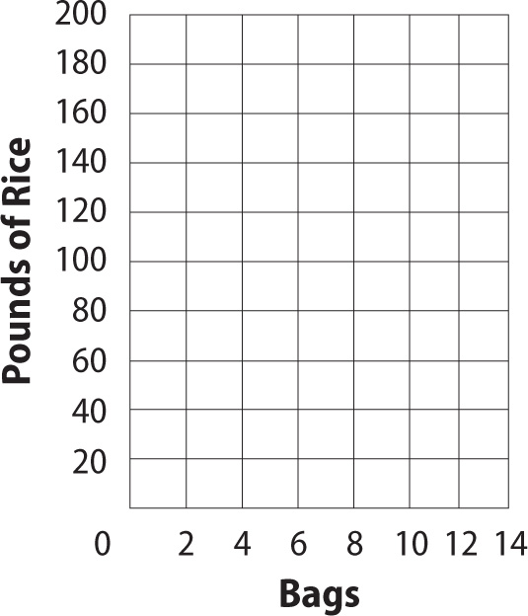

A. p = 15b
B. 30p = 2b
C. p = 2 + b
D. 20p = b

Benchmark Test – First Quarter (cont.)

21. SHORT ANSWER At each mile marker for the first five miles of a marathon, Ellie was 18 seconds,
9 seconds, 14 seconds, 6 seconds, and 3 seconds ahead of her goal pace. What was her mean time ahead of her goal pace?

22. Jacob is $5\frac{5}{6}$ feet tall and Linda is $5\frac{1}{4}$ feet tall.
How much taller is Jacob?
F. $\frac{1}{3}$ feet
G. $\frac{7}{12}$ feet
H. $\frac{3}{4}$ feet
J. $1\frac{1}{9}$ feet

23. What is the quotient, in simplest form, to the following division problem?

$\frac{\frac{4}{5}}{\frac{2}{5}}$
A. $\frac{8}{25}$
B. $\frac{3}{5}$
C. $\frac{2}{5}$
D. 2

24. Identify all sets to which the following number belongs.
4.$\overline{22}$

F. whole, integer, irrational
G. irrational
H. rational
J. whole, rational

25. Which point(s) on the coordinate plane shown are located in Quadrant IV?
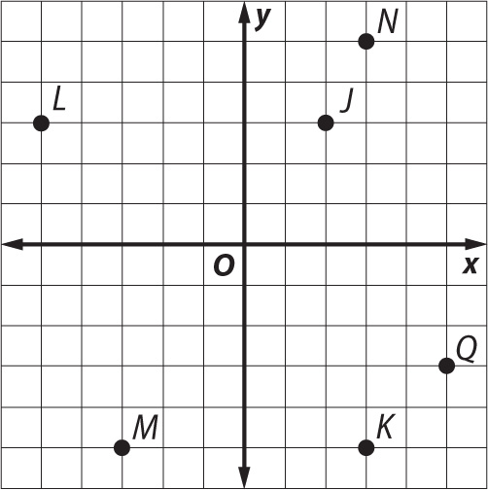

A. Points N and J
B. Points K and Q
C. Point M
D. Point L

