Integer Performance Task: The Weather Report

Weather reports provide very important pieces of information. They allow the reader to interpret temperature changes on a day-to-day basis. The attached document is your performance task and must be completed in an orderly and thorough manner.

You must show all work to receive full credit.

Name:_____________________________________

Class:___________________

Magnet Period:________________

Due Date: ____________________

Pre - Check For Understanding: Write a paragraph including an answer for each part.

a) What is an integer? b) How can you find change between integers? c) What words are associated with positive numbers?
d) What words are associated with negative numbers?

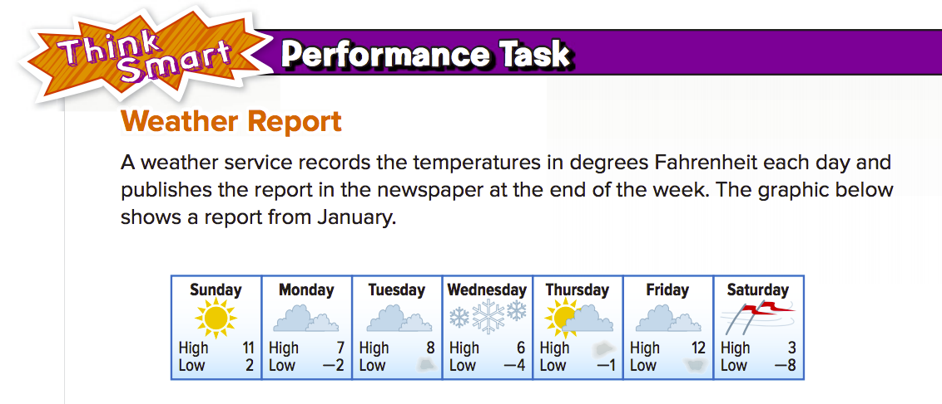

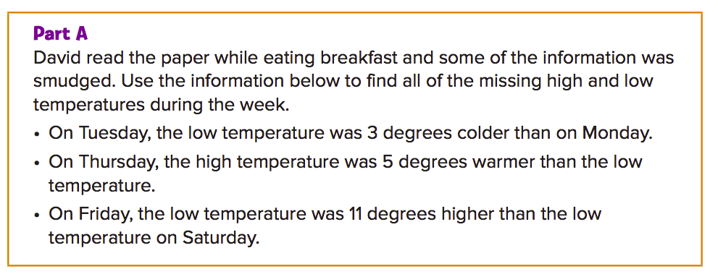

Tuesday | Thursday | Friday
Low: | High: | Low:

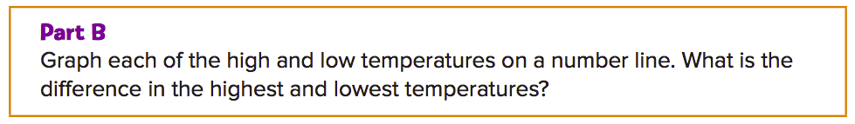
When graphing the high value and low value on the line below label the high with the letter “H” and the low value with the letter “L”
Then, write an expression below the line and evaluate it.

Sunday

Expression: ______________________ = __________

Monday

Expression: ______________________ = __________

Tuesday

Expression: ______________________ = __________

Wednesday

Expression: ______________________ = __________

Thursday

Expression: ______________________ = __________

Friday

Expression: ______________________ = __________

Saturday

Expression: ______________________ = __________

Average: | Average:
Explanation: | Explanation:

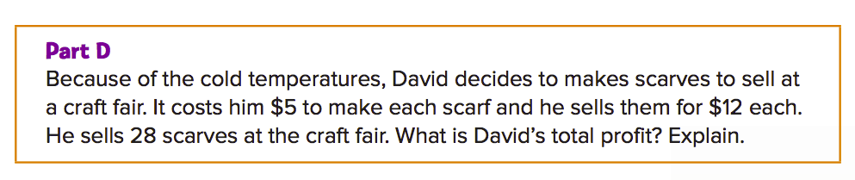

Profit =

Profit =

Side note:
Profit = how much money he makes after he spends money

Profit = Sales – expenses(he spent in making the scarf)

