CH4 Review Sheet – Operations and Fractions

1. 31 × $\frac{1}{8}$

2. $\frac{11}{12}$ × $\frac{7}{8}$

3. Mia is making costumes for a play. Each costume needs 3$\frac{7}{9}$ yards of velvet. She is making 6 costumes. About how much velvet does she need?

What is the value of each expression in simplest form?
4. 15 × $\frac{1}{6}$

5. $\frac{5}{8}$ × $\frac{8}{9}$

6. 1$\frac{3}{5}$ × 3$\frac{1}{2}$

7. Ms. Oliver sewed together a quilt that is 3$\frac{2}{3}$ feet long and 2$\frac{1}{4}$ feet wide. What is the area of her quilt?

8. Use the draw a diagram strategy to solve. Corbin read $\frac{4}{7}$ of the pages in his book. He has 42 pages left to read. How many pages did he read already?
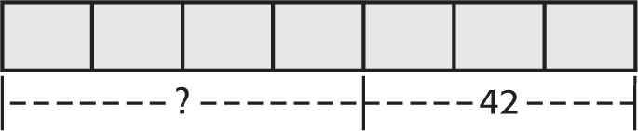

F. 56 G. 84 H. 98 I. 147

9. Joe has 12 cups of soup in a pot. If he pours $\frac{1}{4}$ cup of soup into each bowl, how many bowls will be used?

1. ____________

2. ____________

3. ____________

4. ____________

5. ____________

6. ____________

7. ____________

8. ____________

9. ____________

What is the value of each expression in simplest form?
10. 10 $÷\frac{1}{6}$

11. 7 $÷\frac{3}{4}$

12. 7 ÷ 1 $\frac{1}{2}$

13. 2$\frac{5}{8}÷\frac{3}{4}$

14. 6$\frac{3}{4}÷$ 2$\frac{1}{4}$

15. Lyndsay has 3$\frac{3}{4}$ gallons of paint. She plans on using 1$\frac{1}{4}$ gallons on each room.
How many rooms will she be able to paint?

16. Find $\frac{2}{7}×$ 3$\frac{1}{2}$.

17. Find 4$\frac{1}{2}÷$ 1$\frac{5}{8}$.

18. Six pipes are laid end to end to form a row. Each pipe is 9$\frac{1}{3}$ inches long. How long is the row of pipes, in feet?

19. A box contains 1$\frac{3}{4}$ pounds of beans. How many ounces of beans are in the box?

20. The area of a closet floor measures 3 yards by 3 yards and each custom tile that makes up the flooring is 1$\frac{1}{2}$ square feet. How many tiles are needed to cover the floor?

10. ___________

11. ___________

12. ___________

13. ___________

14. ___________

15. ___________

16. ___________

17. ___________

18. ___________

19. ___________

20. ___________

