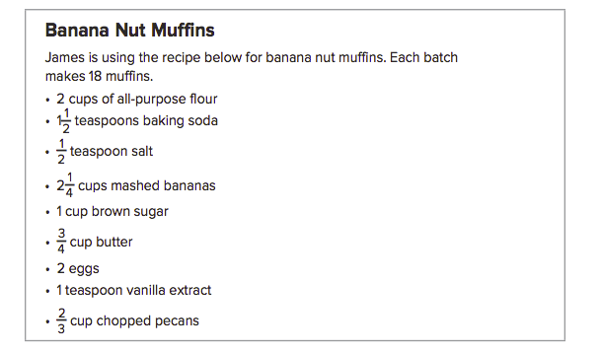

Part A
James doesn’t have enough time to go to the store to get ingredients! He only has ½ cup of brown sugar and needs to work around that measurement.

What factor would he have to decrease the muffin recipe by to use ½ cup of brown sugar? What operation would you use to decrease the recipe? Explain your answer.

On the next page: What are the new measurements for each ingredient? Don’t forget to show work and include units!
Ingredient | Measurements for 18 muffins | Measurement for ____ muffins
Flour
Baking Soda
Salt
Mashed bananas
Brown Sugar
Butter
Eggs
Vanilla
Chopped Pecans

Part B A week later, James wants to try his recipe again. This time he has opportunity to buy the right amount of ingredients to serve 27 friends!

By what factor would he have to increase the muffin recipe by? _______________
What operation would he have to use to increase the recipe?__________________

Complete the chart below representing only part of the recipe’s ingredients:
Ingredient | Measurements for 18 muffins | Measurement for 27 muffins
Flour
Baking Soda
Salt
Mashed bananas

Part C: Reflection on Mathematical Processes:
Explain the steps you would take to multiply mixed numbers:

Explain the steps you would take to divide mixed numbers:

Chapter 4 Fractional Recipe Performance Task – You will be graded based upon the following criteria: You must show all work to receive credit. This is due 1/4/16

Name: Class:
Levels | Mathematical Precision | Presentation | Evidence and Reasoning
Above & Beyond  4 | You made no errors in your calculations.  Each part of the project is complete and correct. | You go above and beyond what is required of you. You put in outstanding effort and show great understanding of the topic. Your project is very neat. | You are able to thoroughly explain how you have reached your answer and solved the given problem. You used mathematical vocabulary when explaining your answer.
At the Top  3 | You made a few errors in your calculations.  Most parts of the project are complete and correct. | You put in the right amount of effort. And have met the appropriate standards. Your project is neat. | You are able to explain how you have reached your answer and solved the given problem. You used some mathematical vocabulary when explaining your answer.
On My Way  2 | You made multiple errors in calculations.  Many parts of the project are incomplete. | You are on your way so don’t give up! There is somewhat of an understanding, but the topic is not clear.  Your project is not neatly presented. | You did not fully explain how you have reached your answer and solved the given problem. You used little/no mathematical vocabulary when explaining your answer.
Not Yet  1 | You made many errors in calculations.  Most of the project is incomplete. | You are not there yet. It looks like you did not apply yourself, like I know you can.  Your project is not neatly presented. | You did not explain what you did or how you came about your reasoning through words, descriptors or pictures.
Score: |  | Glow: | Grow:

