Name:_______________________________________ Date:________________ Test #1 Date:__________

Topics: Add/Subtract Polynomials
Divide polynomial by monomials
Multiply monomial by polynomials
Multiply binomials
Factoring the GCF out of Polynomials

Review Sheet for 7th Grade Magnet Exam #1
For #s 1 – 5 use the operations provided to simplify the expression

1)
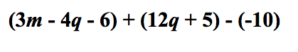

2)
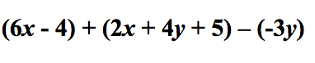

3)
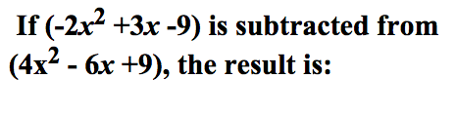

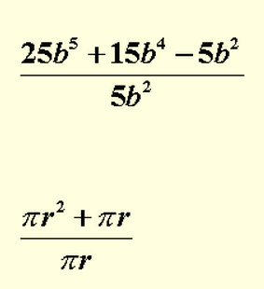
4)

5)

Factor the polynomial and check using distribution:

- 3x⁴y + 18 xy³

- 15w⁴x⁵ + 30wx

Multiplying Binomials:
- (2x + 4) ( 5x -2)

9) (3x² – 5 ) ( -2x + 6)

