**Review Sheet Ch1 Test 1**

**Write the letter for the correct answer in the blank at the right of each question.**

**1.** What is the least common multiple of 6 and 8?

**1.**

**2.** At a summer camp, there are 40 boys out of 70 campers. What is this ratio written as a **fraction** in simplest form?

**2.**

**3.** The table shows the animals at a petting zoo. What is the ratio of goats to the total number of animals?

|  |  |
| --- | --- |
| **Animals at a Petting Zoo** | |
| Chickens | 2 |
| Deer | 4 |
| Donkey | 3 |
| Goats | 6 |

**3.**

**For Exercises 4 and 5, what is each rate written as a unit rate?**

**4.** 9 pages in 3 hours

**4.**

**5.** 20 pounds for $4

**5.**

**6.** What is the gcfof the following pairs of numbers

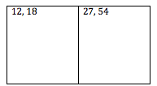

**Review Sheet Ch1 Test 1**

**For Exercises 7 and 8, use the ratio table given to solve each problem.**

**7.** Nicholas bought 5 pens for $3. At this rate, how much will he spend on 10 pens?

|  |  |  |
| --- | --- | --- |
| **Number of Pens** | 5 | 10 |
| **Money Spent ($)** | 3 |  |

**A.** $10 **B.** $6 **C.** $5 **D.** $3 **7.**

**8.** Rashida bought 10 tickets to a concert for $750. At this rate, how much would 5 tickets cost?

|  |  |  |
| --- | --- | --- |
| **Number of Tickets** | 10 | 5 |
| **Money Spent ($)** | 750 |  |

**8.**

**9.** Gina read 120 pages in 4 days. Which reading rate is **equivalent?**

**A.** 75 pages in 3 days **C.** 105 pages in 5 days

**B.** 60 pages in 2 days **D.** 80 pages in 3 days **9.**

**10.** Five notebooks cost $20. At this rate, how much would 4 notebooks cost?

**F.** $16 **G.** $20 **H.** $25 **I.** $30 **10.**

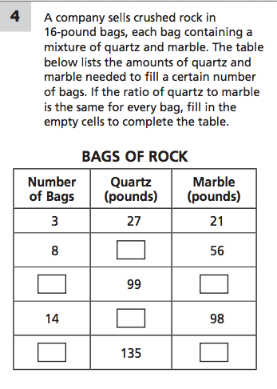 **11.** One serving of a fruit punch recipe serves 4 people. Fill in the table below using this information; then graph it and explain the relationship

