DECIMAL REVIEW

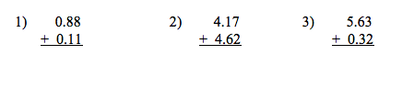

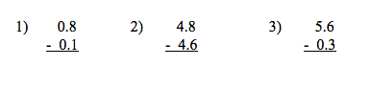

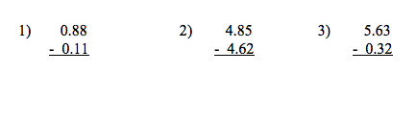

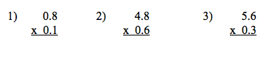

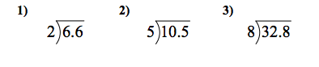

Change the following decimals into fractions. SIMPLIFY!
