Name: _______________________________________________ Date: ___________ Class: ___________ Due: ___________

Review Chapters 1-5 – February Break HW – Show all work!

Read each question. Then fill in the correct answer on the answer sheet provided by your teacher or on a sheet of paper.

Chapter 1: Ratios and Rates

1. The ratio of cats to dogs seen by a veterinarian in one day is 2 to 5. If a vet saw 40 dogs in one day, how many cats did he see?
A. 5 C. 29
B. 16 D. 40

2. A car jack requires a force of 110 pounds to lift a 2,500-pound car. In simplest form, what is the ratio of the car’s weight to the force required to lift the car?

3. The table shows
the cups of whole wheat flour required to make
dog biscuits.
Number of  Dog Biscuits | 10 |  | 35
Cups of Whole  Wheat Flour | 2 |  | ∎

How many cups of whole wheat flour are required to make 35 biscuits?

4. EXTENDED RESPONSE Cesar’s sixth-grade class sorted books in the library. The class sorted 45 books in 90 minutes.

Part A Write an equivalent ratio to find how long it would take to sort 120 books.

Part B How many hours will it take the class to sort 120 books?

Part C Suppose their rate slowed to 30 books in 90 minutes. How long would it take the class to sort the 120 books? Explain your reasoning.

Chapter 2: Fractions, Decimals and Percents

5. The graph shows the elements found in Earth’s crust. What fraction of Earth’s crust is silicon?
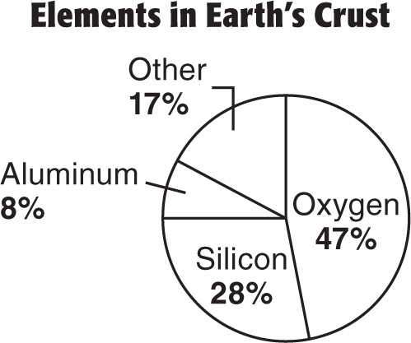

F. $\frac{1}{28}$ H. $\frac{2}{5}$

G. $\frac{7}{25}$ I. $\frac{1}{2}$
6. The fastest fish in the world is the sailfish. If a sailfish could maintain its speed, as shown in the table, how many miles could the sailfish travel in 6 hours?
Hours Traveled | 0 | 1 | 2 | 3 | 4 | 5 | 6
Miles Traveled | 0 | 68 | 136 | 204 | 272 | 340 | ?

A. 6 miles C. 408 miles

B. 68 miles D. 476 miles

7. Carlita planted 4 flowers in 9 minutes. About how many flowers can Carlita plant in 36 minutes?

8. What is the ratio of people to buses?
6 buses | 150 people

F. 1:25 H. 6:150

G. 25:1 I. 156

Chapter 3: Compute with Multi-Digit Numbers

9. A model plane is 100 times smaller than an actual plane. The length of the model is 4.8 inches. What is the actual length of the plane?
A. 480 feet C. 20 feet
B. 40 feet D. 8 feet

10. Malabar Middle School is raising money for a local charity. Their goal is to raise $500 by their holiday break. If they have 10 days before their break, what is a reasonable amount that they should collect each day to reach their goal?
F. $5 H. $50
G. $25 I. $100

11. SHORT RESPONSE Rita bought 5.7 pounds
of bananas and 2.8 pounds of apples. Write a multiplication expression and find the total
cost for the fruit. Round to the nearest cent.
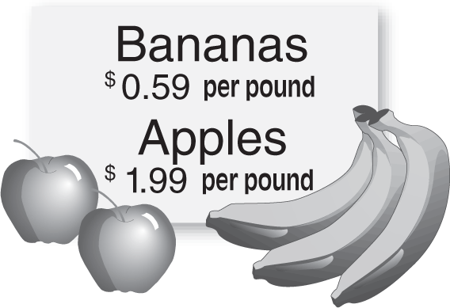

12. Malabar Middle School is raising money for a local charity. Their goal is to raise $500 by their holiday break. If they have 10 days before their break, what is a reasonable amount that they should collect each day to reach their goal?
F. $5 H. $50
G. $25 I. $100

13. Ignacio cut the board shown into 4.5 –inch pieces. How many pieces can he cut?
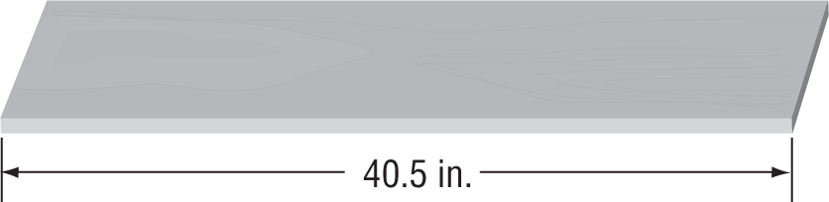

A. 6 C. 8
B. 7 D. 9

Chapter 4: Multiply and Divide Fractions

14. Albert used $\frac{3}{8}$ of a half-gallon of paint. What fraction of a gallon of paint did he use?

A. $\frac{3}{4}$ B. $\frac{2}{5}$ C. $\frac{3}{16}$ D. $1\frac{1}{3}$

15. Courtney found the area of her notebook paper shown. What is the width of the piece of notebook paper?

F. 8 inches
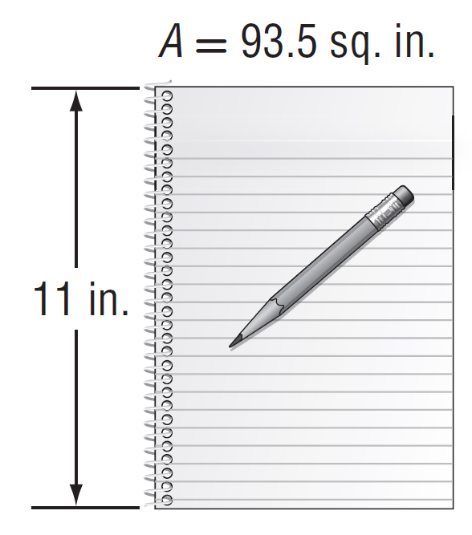
G. 8.5 inches
H. 9 inches
I. 9.5 inches

16. EXTENDED RESPONSE Rose’s recipe for snack mix is shown. The recipe serves 12 people but Rose wants to make enough for 30 people.

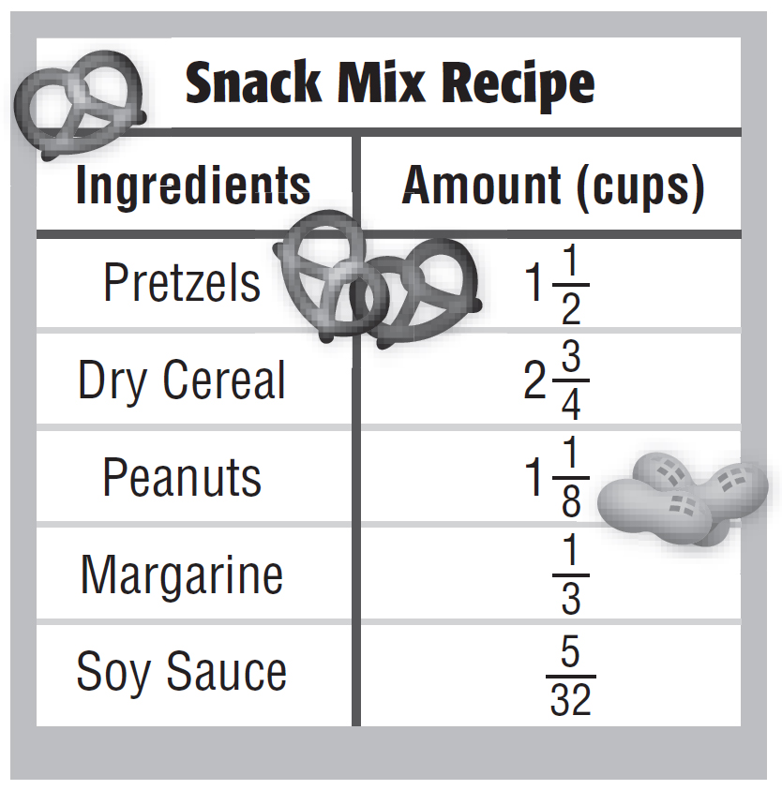

Part A Explain how Rose can calculate the amount of each ingredient she needs to serve 30 people.

Part B How much of each ingredient will Rose need?

Part C How many cups of dry snack mix will there be in all? Explain your answer.

17. SHORT RESPONSE The table shows J.T.’s training schedule for a marathon. If the pattern continues, how many minutes will he run on Day 8?
Day | Running Time (min)
1 | 20
2 | 22
3 | 24
4 | 26

18. Which point best represents the location of the ordered pair $\left(1\frac{1}{4}, 2\right)$?
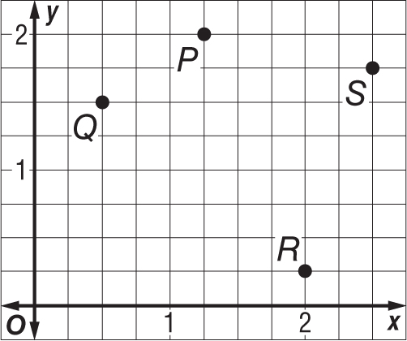

F. Point P H. Point R
G. Point Q I. Point S

19. Which point on the grid below corresponds to the ordered pair (5,2)?
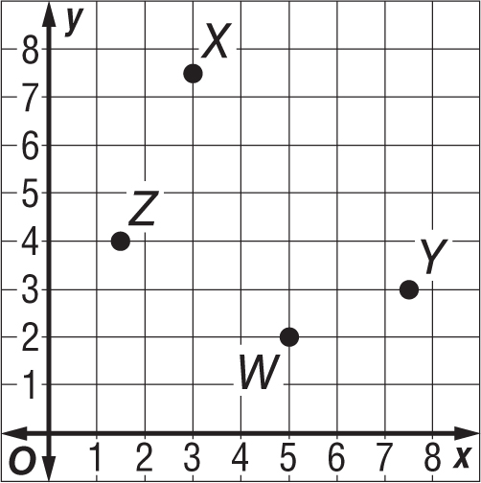

A. Point W C. Point Y
B. Point X D. Point Z

